> library(readr)
> library(dplyr)
> library(ggplot2)
> library(stringr)
> library(tidyr)
> sd <- read_csv("datasets/sensitivity runs/SIRH_Sensitivity.csv")
Rows: 100 Columns: 1501
── Column specification ────────────────────────────────────────────────
Delimiter: ","
dbl (1501): Days, ="Run 1: In Hospital", ="Run 2: In Hospital", ="Ru...

ℹ Use `spec()` to retrieve the full column specification for this data.
ℹ Specify the column types or set `show_col_types = FALSE` to quiet this message.
> sd_tidy <- sd %>%
+ pivot_longer(cols=!Days,names_to="Variable",values_to="Value") %>%
+ mutate(Variable=str_replace_all(Variable,'\"',""),
+ Variable=str_replace(Variable,"=","")) %>%
+ separate(Variable,into=c("Run","Variable"),sep = ":") %>%
+ mutate(Variable=trimws(Variable)) %>%
+ separate(Run,c("TempRun","Run"),sep = " ",convert = TRUE) %>%
+ select(Run,Days,Variable,Value)
> p1 <- ggplot(filter(sd_tidy,Variable=="In Hospital"),
+ aes(x=Days,y=Value,colour=Run,group=Run))+geom_line()

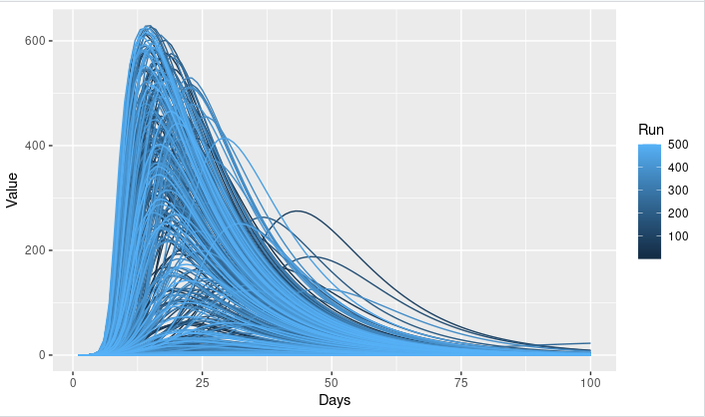

> sd_wide <- sd_tidy %>%
+ pivot_wider(names_from = Variable,values_from = Value)
> summ <- sd_wide %>%
+ group_by(Run) %>%
+ summarise(PeakH=max(`In Hospital`),
+ Contacts=first(Contacts),
+ VF=first(VF)) %>%
+ ungroup()
> arrange(summ,desc(PeakH))
# A tibble: 500 × 4
Run PeakH Contacts VF
<int> <dbl> <dbl> <dbl>
1 242 629. 17 0.0011
2 475 626. 18 0.0029
3 225 626. 16 0.0007
4 388 624. 19 0.0043
5 258 623. 17 0.0023
6 491 617. 18 0.0049
7 220 614. 18 0.0055
8 342 614. 17 0.0041
9 52 613. 19 0.0069
10 304 611. 14 0.0005
# ℹ 490 more rows
# ℹ Use `print(n = ...)` to see more rows
> p2 <- ggplot(summ,aes(x=Contacts,y=VF,size=PeakH,colour=PeakH))+
+ geom_point()+
+ scale_color_gradient(low="blue", high="red")+geom_jitter()

